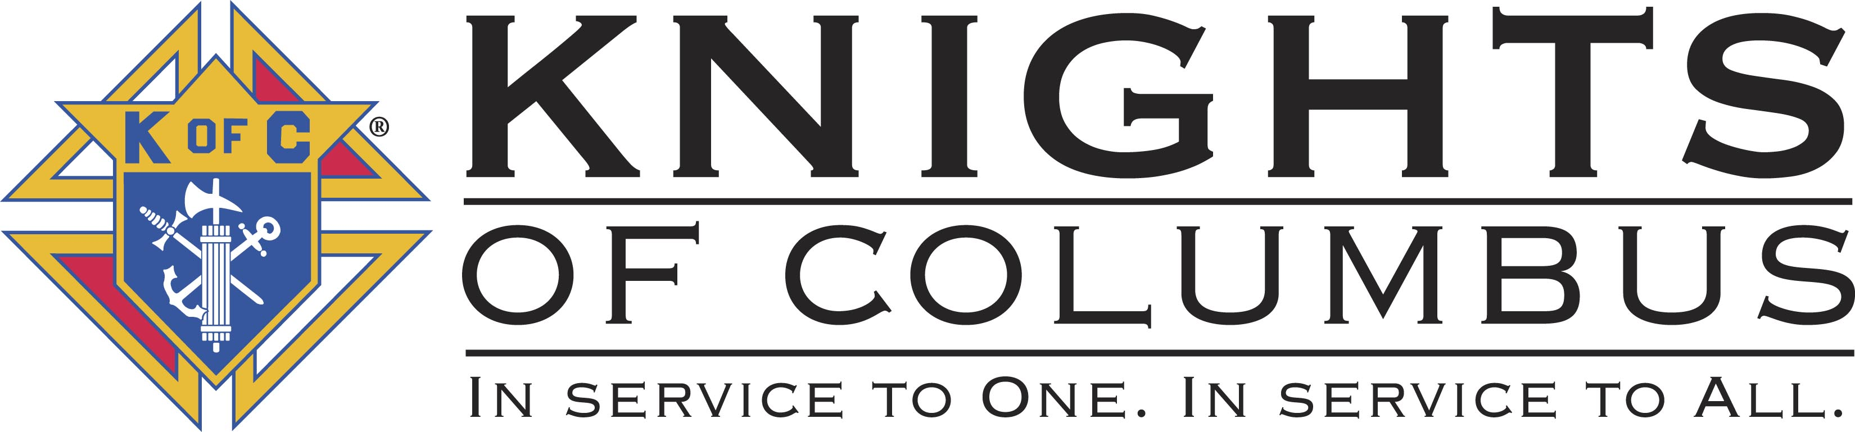

Knights of Columbus – Council 1498
9905 Foothills Canyon Blvd.
Highlands Ranch, CO 80129
http://www.knights1498.org/

January 14 , 2011

Donor Name
Donor Address
Donor City, State, ZIP

Dear ____________________,
On behalf of the Knights of Columbus, I want to personally thank you for your generous contribution of ___________________________. It is truly a blessing to receive such gifts in support of our charitable efforts.
Please keep this written acknowledgment of your donation for your tax records. The Knights of Columbus is a 501(c)8 fraternal non-profit organization and our federal employer identification number (FEIN) is: 26-0092629. No goods or services were given in exchange for this donation.
It is the responsibility of the donor to determine the fair market value of the donated items. Please consult your tax advisor with any questions you may have regarding fair market value and income tax deductibility.
Thank you again for your generosity.
Very truly yours,

Brian Rollins
Grand Knight

